**TypeScript**

### What is TypeScript?

## It is an open-source object-oriented language developed and maintained by Microsoft.

## It is a superset of JavaScript that compiles to plain JavaScript.

## Basically, TypeScript is the ES6 version of JavaScript(enhanced version of JavaScript) with some additional features.

## TypeScript trans piles to JavaScript and will run in any environment that native JavaScript runs.

## You may use TypeScript for both front end and back-end applications.

## Builds on JavaScript.(TypeScript is using JavaScript internally)

## Compile time language.

## Catch errors early in the editor.

## TypeScript code converts to JavaScript, which runs anywhere JavaScript runs.

## Whatever code we are writing in typescript it converts into JavaScript with the help of typescript compile. From JavaScript it will be executed in browser or node etc.

## Because JavaScript is run time language it will not give you the error at compile time but in TypeScript before running the program itself, we will get to know what kind of error it is.

## Extension is **.ts** while creating scripts.

### Why TypeScript?

## Before TypeScript, JavaScript is well established in the market.

## Basically, JavaScript is used for developing both client and server-side applications using different types of framework like

## Angular or React.js(client-side application framework)

## Node.js(server-side application framework)

## JavaScript is a dynamic programming language with no type system. In JavaScript we can define the variables without having any data types. Depends upon the data it will automatically assign the type of that particular variable(also called as no type system).

## So, we need a language with type system which increases the code quality, readability and makes it an easy to maintain and refactor code base.

## More importantly, errors can be identified at compile time rather than at run time.

## So, without the type system, it is difficult to scale JavaScript to build complex applications.

## Hence the reason to use TypeScript is that it supports type system and allows JavaScript to be used at scale to build complex applications.

### How to use TypeScript?

## TypeScript code is written in a file with **.ts** extension and then compiled into JavaScript using the TypeScript compiler.

## TypeScript file can be written in any code editor.

## TypeScript compiler needs to be installed on our platform. Once installed, the command

## **tsc <filename>.ts** compiles the TypeScript code into a plain JavaScript file.

## JavaScript files can then be included in the HTML and run on any browser.



### Features of TypeScript

### Cross-platform

## The TypeScript compiler can be installed on any operating system such as Windows, Mac and Linux

### Object-Oriented Language

## Provides features like Classes, Interfaces, and Modules.

### Static Type Checking

## Uses static typing and helps type checking at compile time. Thus, we can find errors while writing the code without running the script.

## We must specify the data type of the variable unless we specify the datatype we cannot define the variable.

### Optional Static Type Checking

## If we want to declare the variables without specifying the datatype then that is also possible.

## TypeScript also allows optional static typing in case you are using the dynamic typing of JavaScript.

### DOM Manipulation

## We can use TypeScript to manipulate the DOM for adding or removing elements.

### ES 6 Features

## TypeScript includes most features of planned ECMAScript 2015(ES 6,7) such as class, interface, Arrow functions etc.

### Advantages of TypeScript

## Open-source language with continuous development and maintenance by Microsoft

## Run on any browser or JavaScript Engine.

## Similar to JavaScript and uses same syntax and semantics. All of TypeScript code finally gets converted into JavaScript.

## Also closer in syntax to back-end languages like Java. This helps backend developers write front-end code faster.

## It can be called from an existing JavaScript code. Also works with existing JavaScript frameworks and libraries without any issues.

## Has support for the latest JavaScript features.

### Key difference between JavaScript and TypeScript

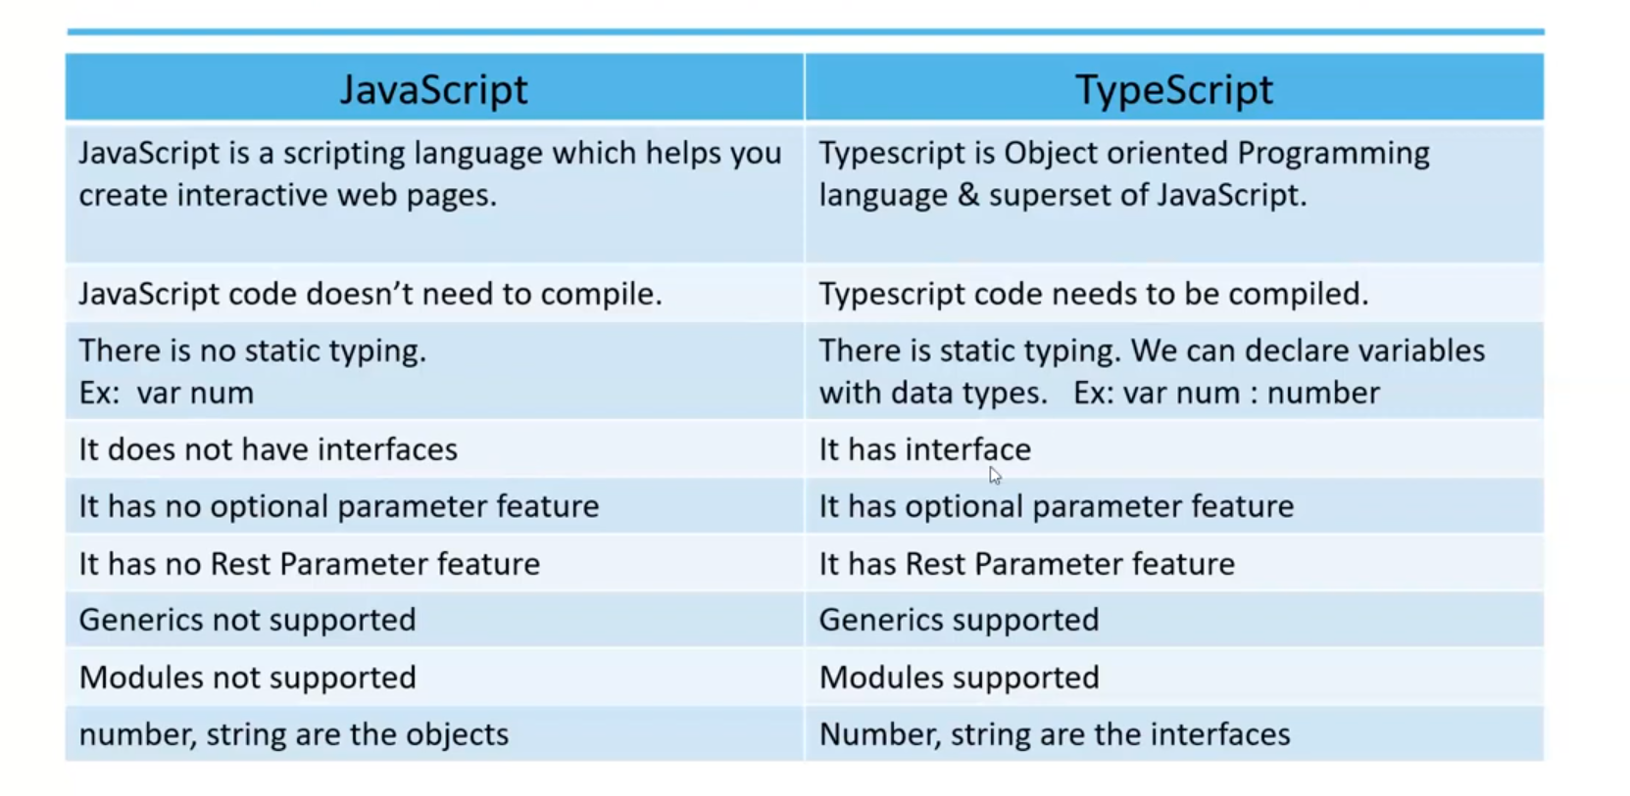

### Installation and Setup

### Pre-requisites

## Node JS

## TypeScript

## Visual Studio Code

### Install Node.js

## **Step 1:** Download and install node.js.

## **Step 2:** To check whether it is installed successfully run the command node --version.

### Install TypeScript

### Approach 1: via npm

## npm install typescript --save-dev

### Globally Installing TypeScript

## npm install -g typescript.

### To check whether it is installed successfully.

## tsc -v

### Approach 2: With Visual Studio

### Install Visual Studio Code

## **Step 1:** Download and install Visual Studio Code

### Process

## Whatever code we are writing we must compile it using tsc(TypeScript Compiler) then it will be converted(create one file(same code) with extension js) to JavaScript.



## Then use NodeJS or browser to execute the file.



## We will be defining the type of the data.

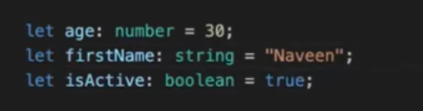

### Variables

## It is a container which can hold data.

## TypeScript follows the same rule as JavaScript for variable declarations.

## JavaScript is not a typed language. It means we cannot specify the type of a variable such as number, string, Boolean etc.

## However, TypeScript is a typed language, where we can specify the type of a variables.

## Variables can be declared using const, let, var.

### Four ways to declare variables:

## Both type and initial value

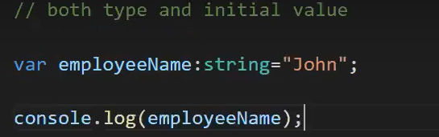

## Only the type

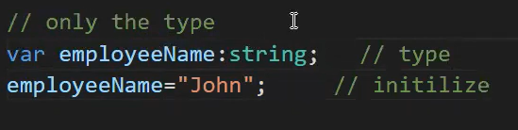

## Only the initial value

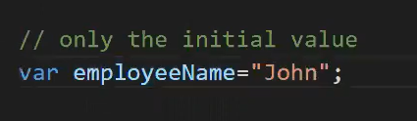

## Without type and initial value

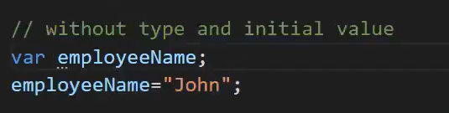

### Var

## Variables declared using **var** are available within the function.

## If we declare them outside the function, then they are available everywhere(global variable).

## If we declare them inside a code block, they are still scoped to the enclosing function.

## We can update or redefine a var variable.

### Variable inside the function

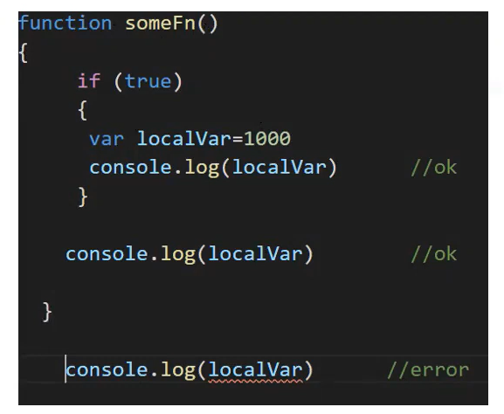

### Variable outside the function(global)

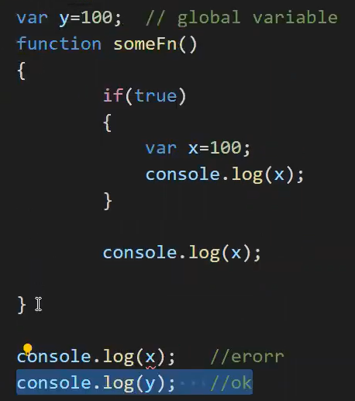

### let

## The variables declared using let can only be used in the code block where we declare them. Outside the code block, they are invisible.

## If they are outside the code block, but withing the function body then they become function scoped.

## let variable cannot be redeclared or updated within the same scope.

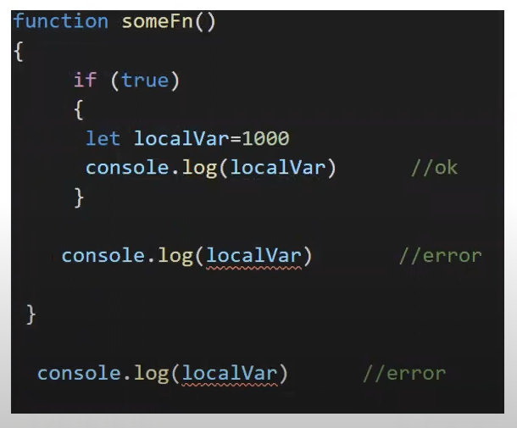

### const

## We must declare a const variable with an initial value.

## The value cannot be reassigned again.

### Type Annotations

## Explicitly specifying the data type of variables, function parameters, and return values.

## This annotation enhances code clarity and enables TypeScript's static type checking to catch errors during compilation.

## This improves code quality and maintainability.



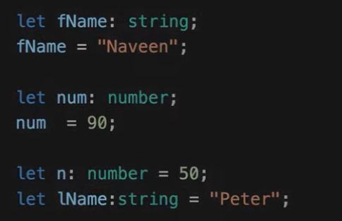

### Type Inference

## TypeScript will automatically detect variables data type, functions return type, Object types, Array Types, etc.

## This detection is based on the values assigned to the variables and the usage of the code or function calls.

## It will decide the type of the variables during compile time based on the value we pass.

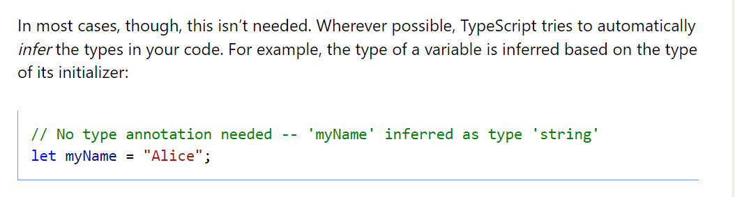



### Datatypes

## It is used to define a type of data the variable can hold.

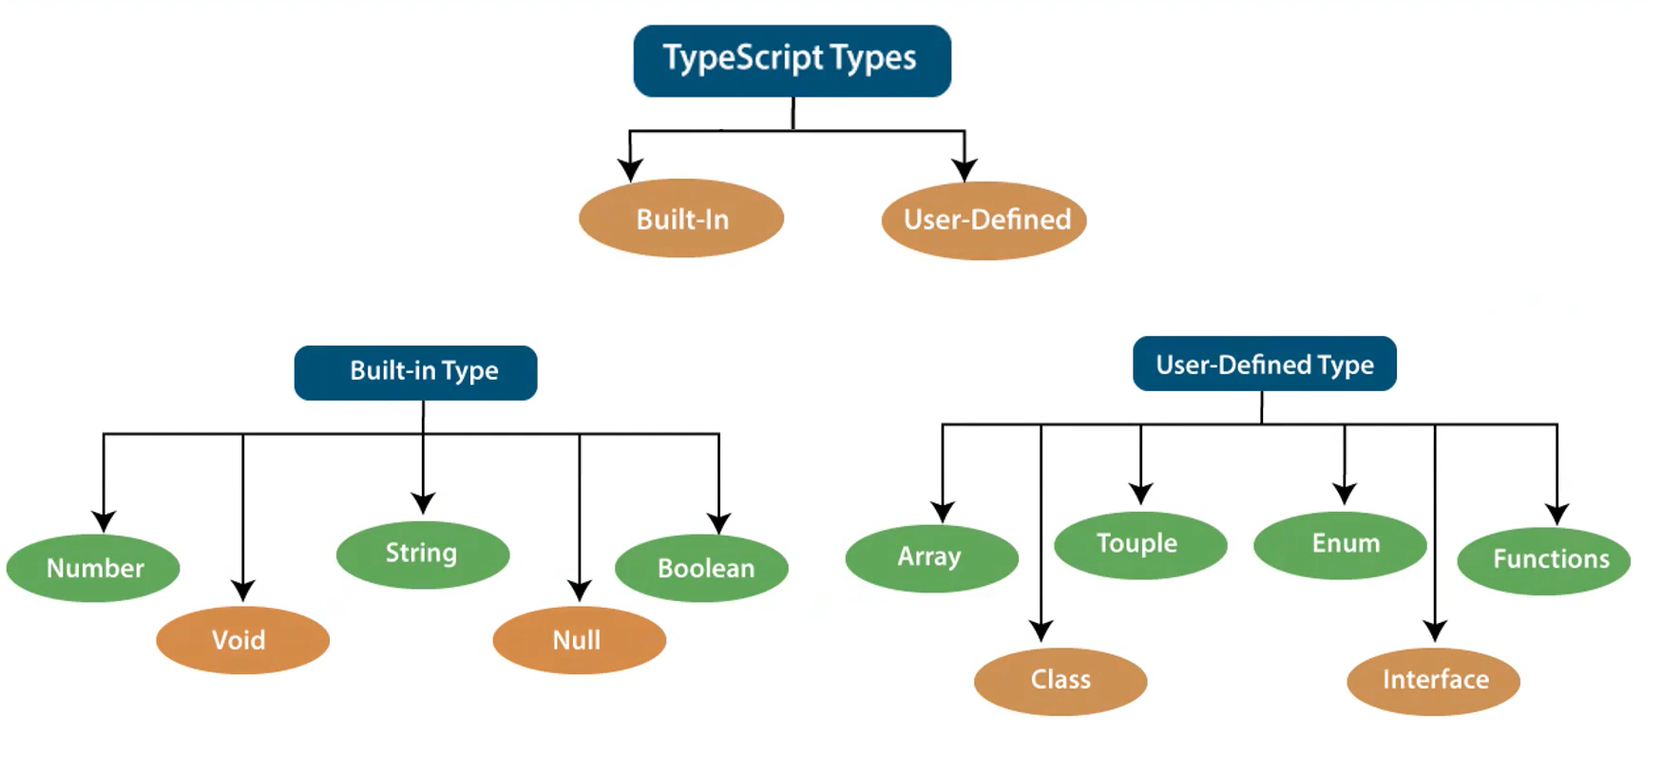

### Number

## It is used to represent both Integer as well as Floating-Point numbers.





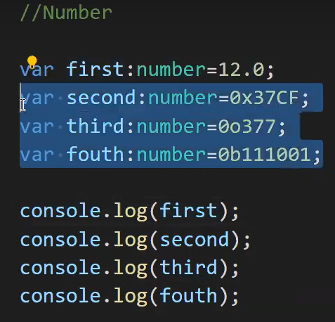

### Boolean

## Represents true and false.

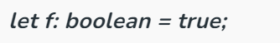

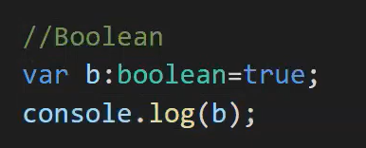

### String

## It is used to represent a sequence of characters.



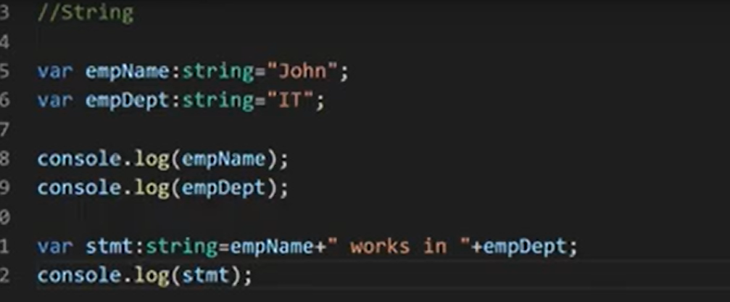

### Void

## Generally used on function return-types

## Also used in variable but it allows only undefined to be assigned.

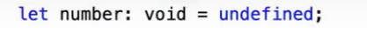

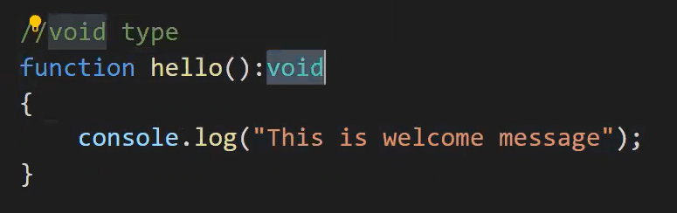

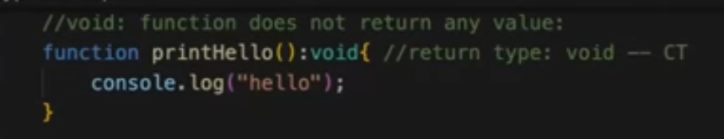

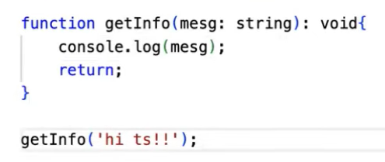

### Null

## It is used when an object does not have any value.



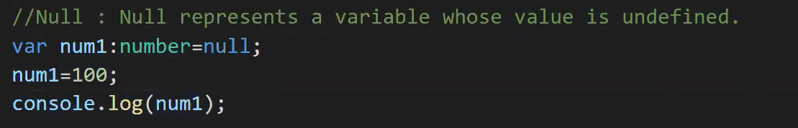

### Undefined

## Denotes value given to uninitialized variable.



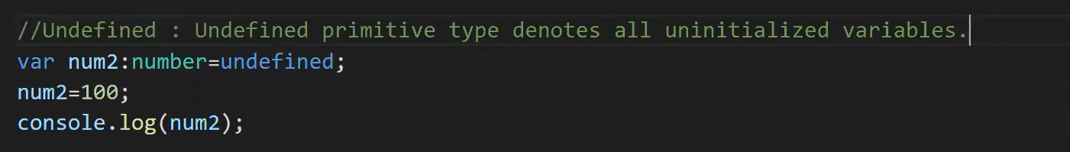

### Any

## It is a special datatype, also the super data-type of all data types

## If a variable is declared with **any** data type, then any type of value can be assigned to that variable.

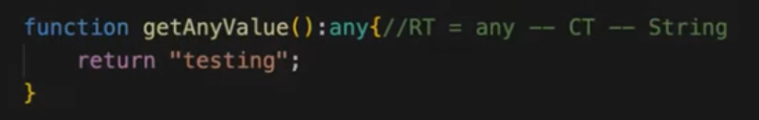

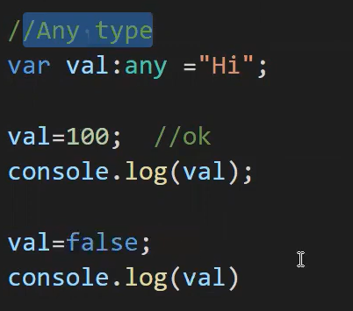

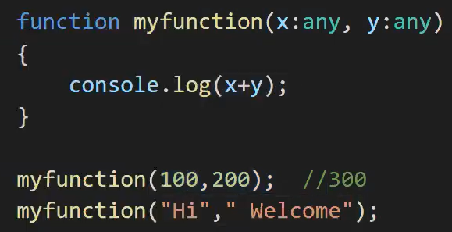

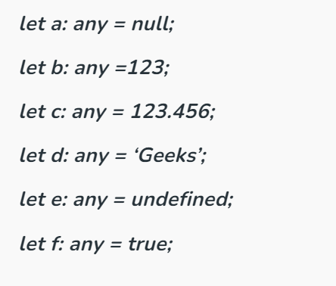

### Never

## TypeScript introduced a new type never, which indicates the values that will never occur.

## The never type is used when you are sure that something is never going to occur.

## For example, you write a function which will not return to its end point or always throws an exception.

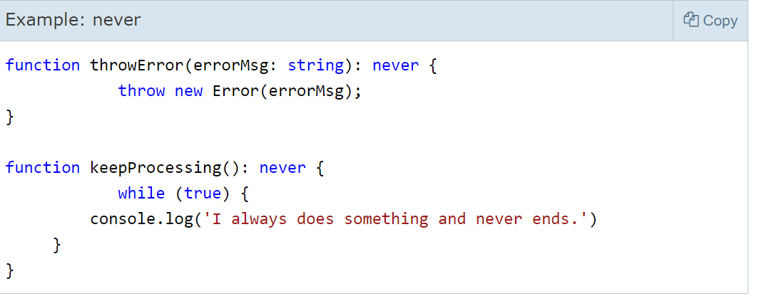

### trim()

## Remove leading and trailing spaces.

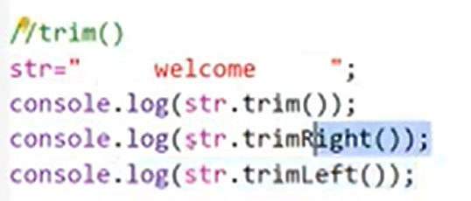

### Arrays

## An array is a special type of data type which can contain elements of the **same data type or elements of varying data types**. It offers flexibility in terms of the data it can hold.

## The array is index-based storage, where the first element stored at index 0.

## Arrays are useful when you want to store data that has a variable and **unknown structure**, such as lists of items, collections of values, multidimensional arrays, etc.

## In an array, **the order is not important**.

### Types

## Single Dimensional Array

## Multi-Dimensional Array

### Array declaration and Initialization:

## TypeScript also supports arrays. There are two ways to declare an array:

### ****Using square brackets.****



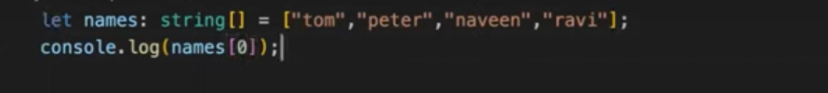

### ****Using a generic array type.****



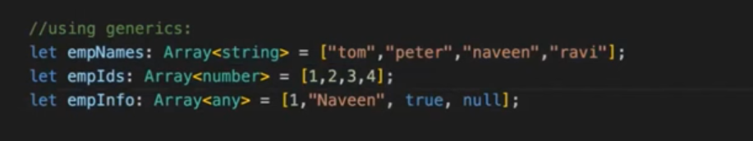

### Single Type Array(Similar/homogeneous data type)

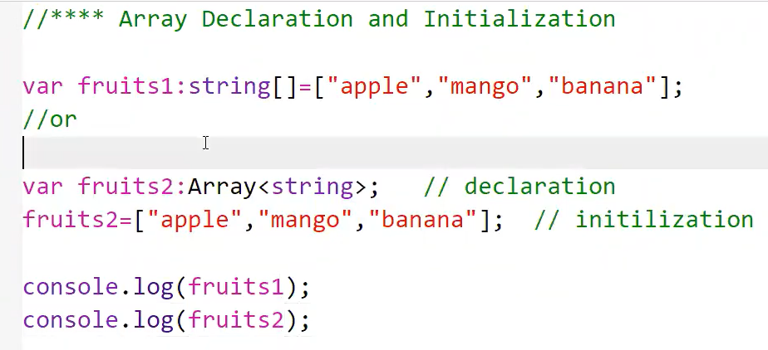

### Multiple Type Array(different/heterogenous data type)

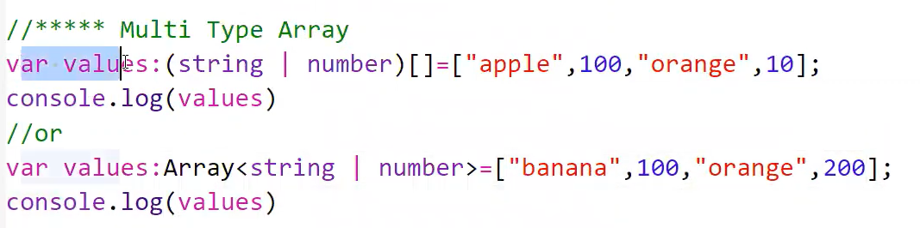

### Single Dimensional Array

## It is the simplest form of an array that contains only one row for storing data.

### Multi-Dimensional Array

## It is an array of arrays, meaning it is a matrix of rows and columns.

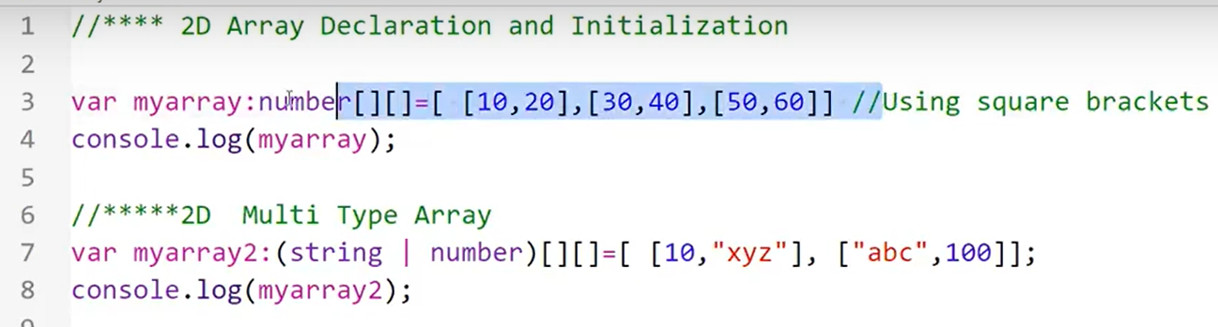

### Accessing multi-dimensional array

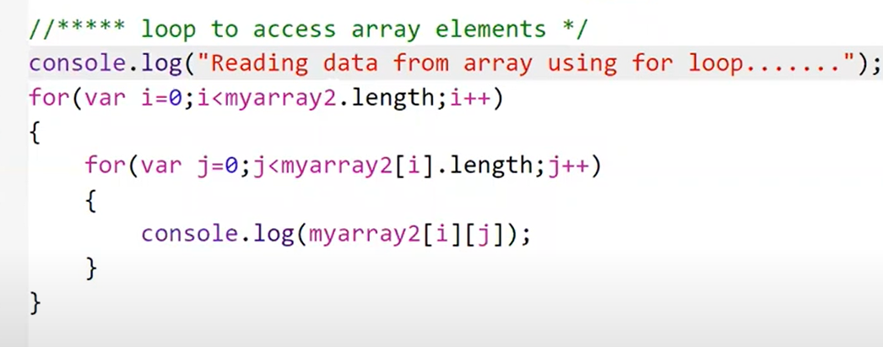

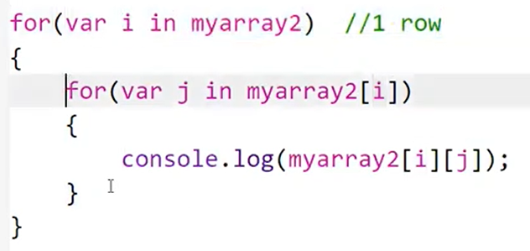

### Tuple

## Tuples are a special type of array where the type of each element is known and fixed.

## Tuples are useful when you want to store data that has a **fixed and known structure**, such as coordinates, key-value pairs, function parameters and return types, etc.

## Tuples in TypeScript are designed to have a **fixed length** in terms of the types of elements they can contain.

## This means that when you declare a tuple, you specify the data types for each position, and TypeScript enforces these types.

## However, you can still add elements to a tuple using the push method because TypeScript does not prevent you from doing so.

## Tuples in TypeScript allow you to specify the data type for each element at a specific position. This means that each element in a tuple has a fixed, known data type, and the data type is enforced.

## **The order and position** of elements in a tuple are **guaranteed(important)**.

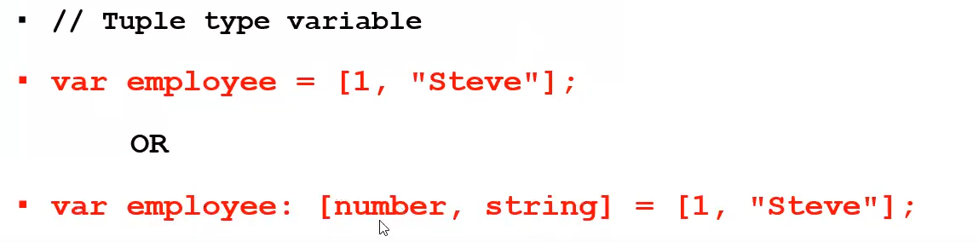

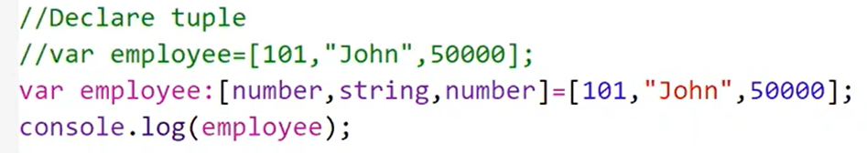

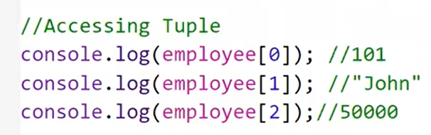

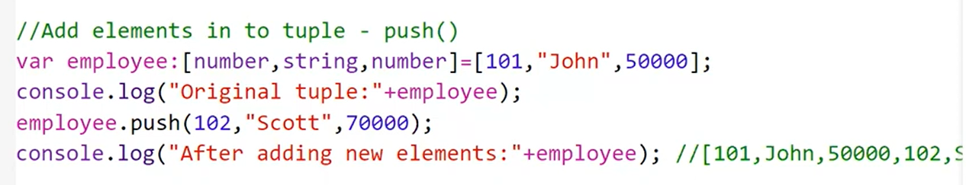

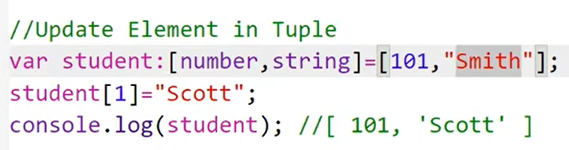

## Tuple also holds multiple array elements.

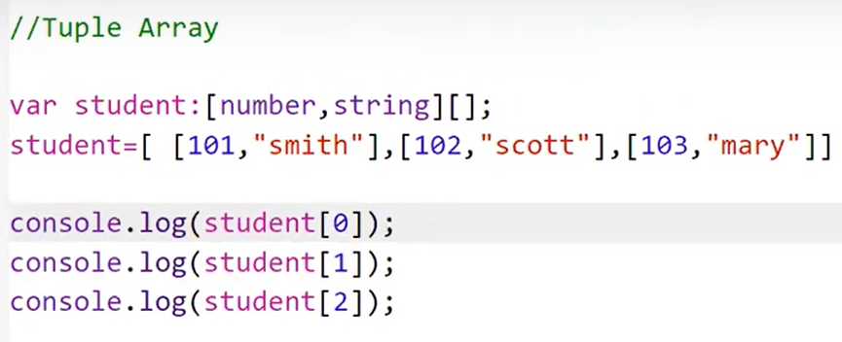

### Union | (OR)

## **Union types** are used when a value can be more than a single type.

## The TypeScript union can combine one or two different types of data (i.e., number, string, float, double, etc).

## It is the most powerful way to express a variable with multiple types.

## Use pipe (‘|’) symbol to combine two or more data types to achieve Union type.

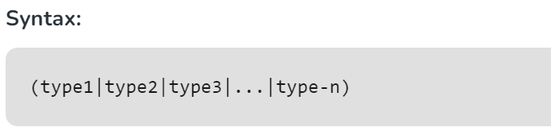

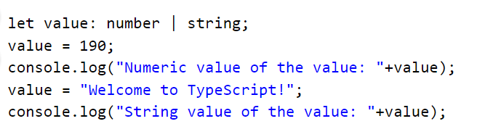

### ****Function Parameter as Union Type****

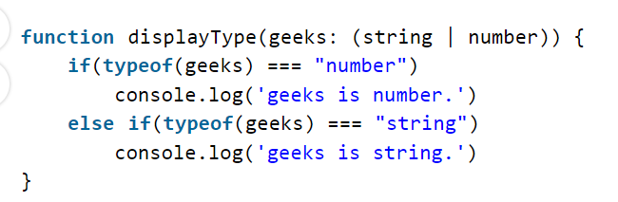

### Enum

## An **enum** is a special "class" that represents a group of constants (unchangeable variables).

## Enums come in two flavors **string** and **numeric**.

### Numeric Enums - Default

## By default, **enums** will initialize the first value to 0 and add 1 to each additional value.

## You can set the value of the first numeric **enum** and have it auto incremented from that

## You can assign unique number values for each enum value. Then the values will not be incremented automatically.

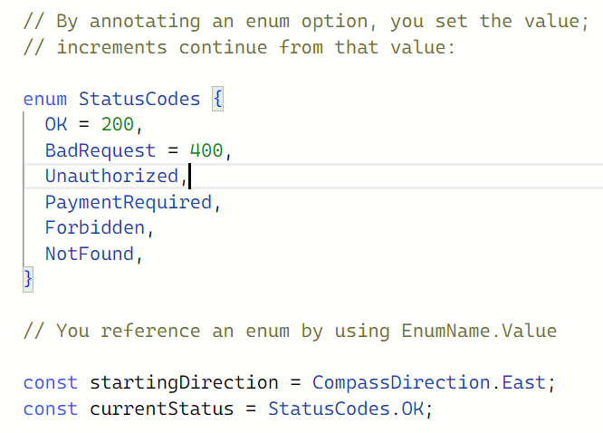

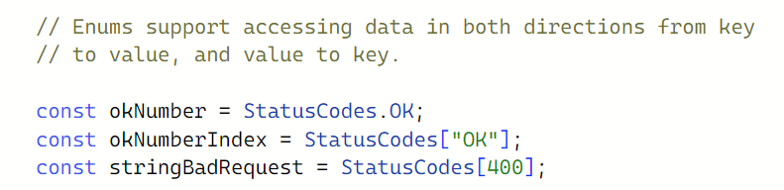

### String Enums

## Enums can also contain strings.

## This is more common than numeric enums, because of their readability and intent.

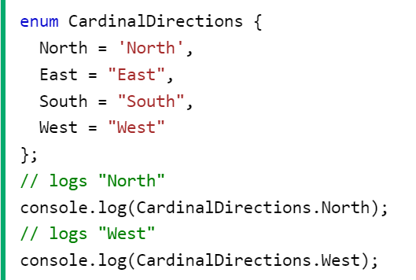

### Functions

## Functions are primary block of any program.

### Code reusability:

## We can call a function several times without writing the same block of code again. The code reusability saves time and reduces the program size.

### Less Coding

## Functions makes our program compact. So, we don’t need to write many lines of code each time to perform common task.

### Easy to debug:

## It makes the programmer easy to locate and isolate faulty information.

### Types

### Named Function

## We can declare and call a function by its given name.

### Without Arguments

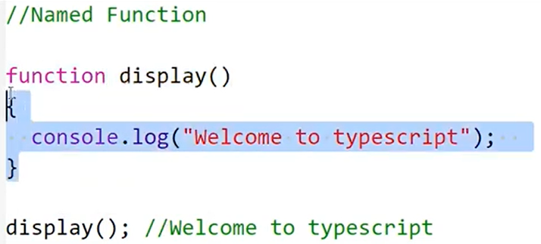

### With Arguments

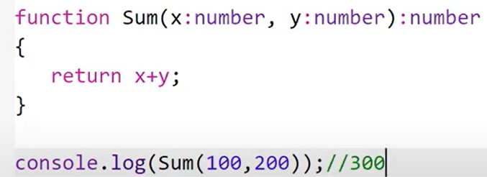

### Anonymous Function

## It is defined as an expression.

## This expression is stored in a variable. So, the function itself does not have a name.

## These functions are invoked using the variable name that the function is stored in.

### Without Arguments

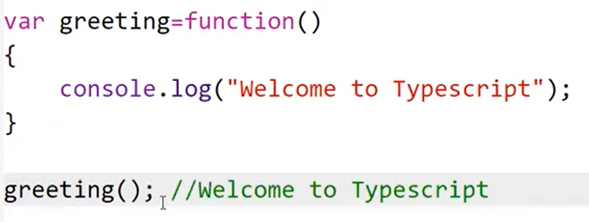

### With Arguments

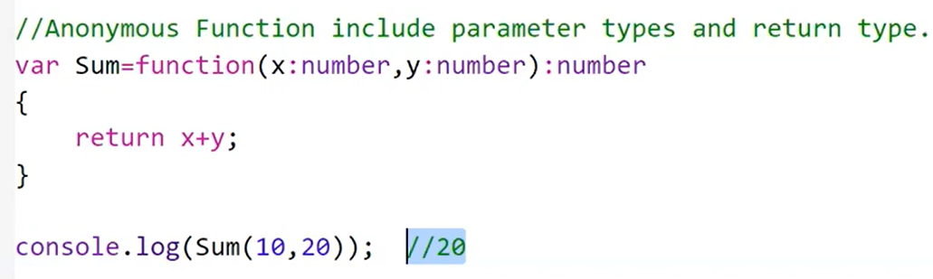

### Function Parameters

## Parameters are values or arguments passed to a function.

## In TypeScript, the compiler expects a function to receive the exact number and type of arguments as defined in the function signature.

## If the function expects three parameters, the compiler checks that the user has passed values for all three parameters. It checks for exact matches.

### Types

### Optional Parameter

## This feature allows us to pass or omit values for these parameters when invoking the function without triggering any errors.

## To mark a parameter as optional, we append “?” at the end of the parameter declaration.

## If we call the function which needs two parameters and only provide a value for one parameter, the optional parameter will take the value of “undefined” by default.

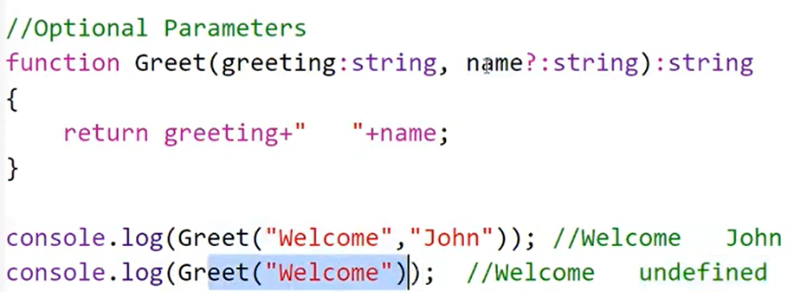

### Default Parameter

## The default parameters allow us to initialize the parameter with default values if no value or undefined is passed as the argument.

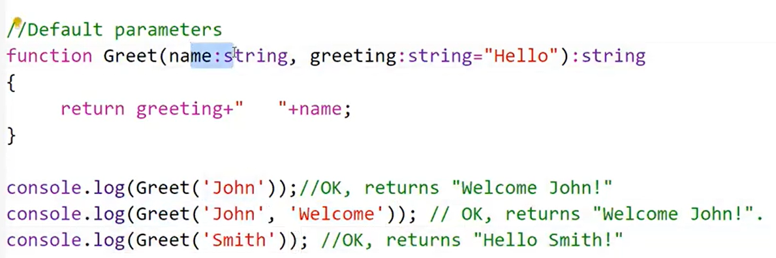

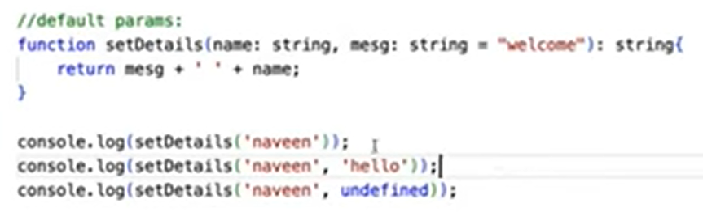

### Arrow Functions

## Fat arrow notations are used for anonymous functions i.e. for function expressions.

## They are also called lambda functions in other languages.

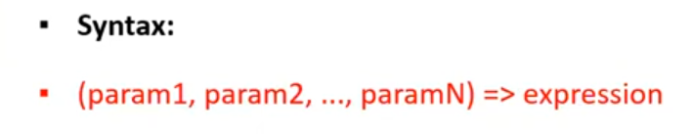

### With Arguments

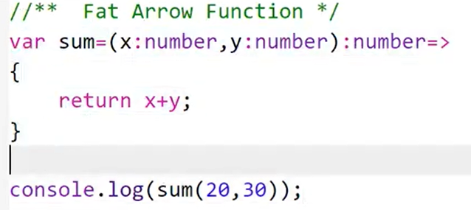

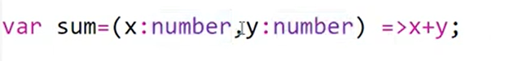

### Without Arguments

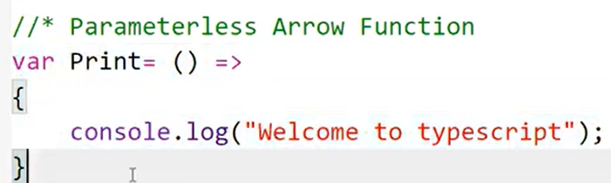

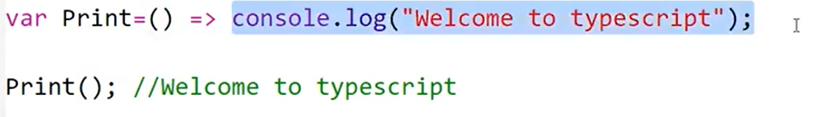

### Function Overloading

## TypeScript provides the concept of function overloading.

## We can have multiple functions with same name but different parameter types and return type. However, the number of parameters should be same.

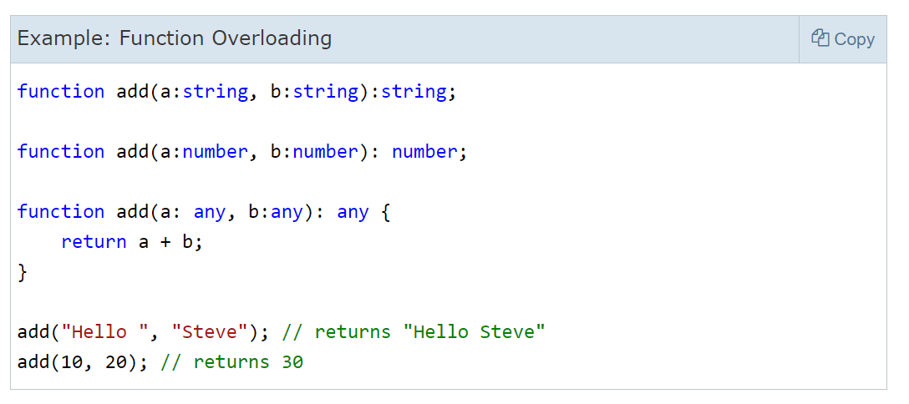

## Function overloading with different number of parameters and types with same name is not supported.

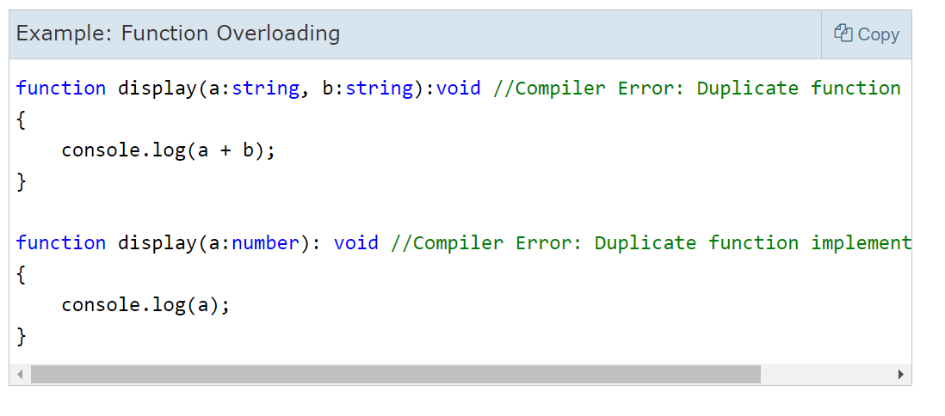

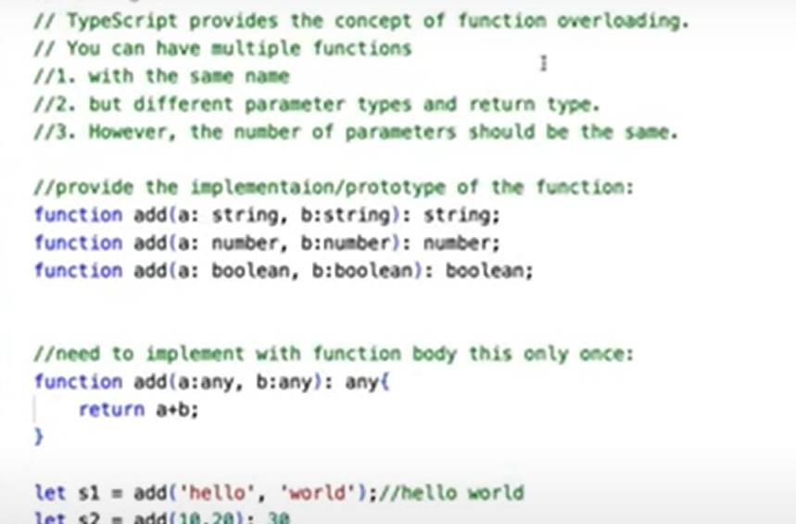

### Rest Parameters

## If the number of parameters that a function will receive is not known or can vary, we can use the rest parameters.

## We can use the rest parameters denoted by ellipsis …

## We can pass zero or more arguments to the rest parameter. The compiler will create an array of arguments with the rest parameter name provided by us.

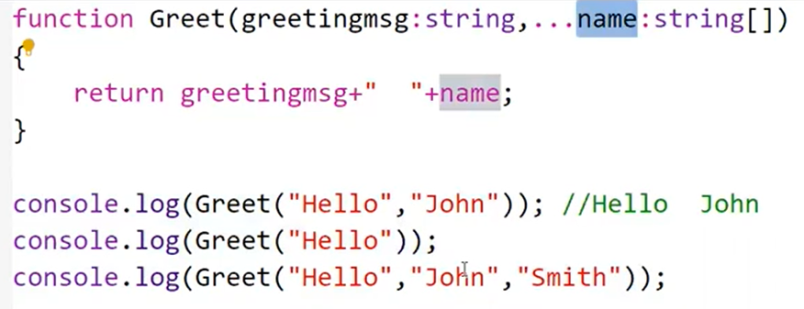

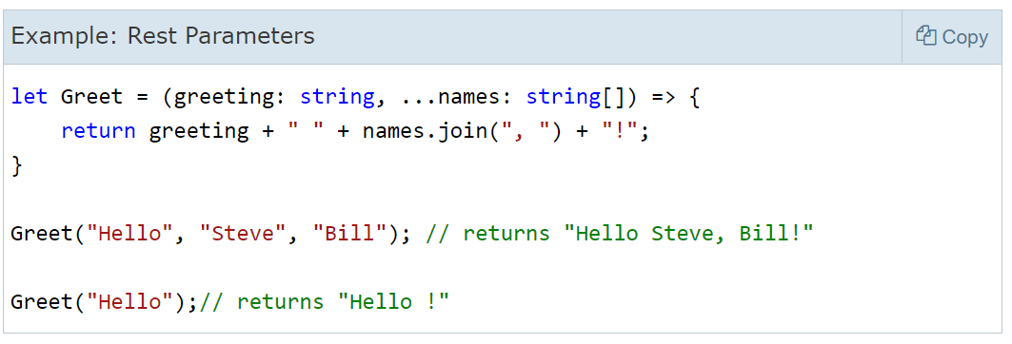

## Rest parameters must come last in the function definition, otherwise the TypeScript compiler will show an error. The following is not valid.

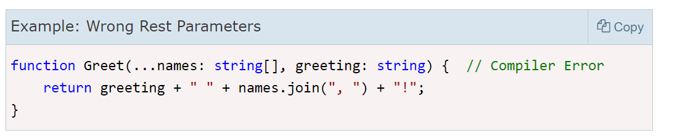

### Class

## Class is logical entity. It includes constructor, properties, and methods.

## It is a blueprint and based on this we can create multiple objects.

## We can create any number of objects for one class, but these objects are independent.

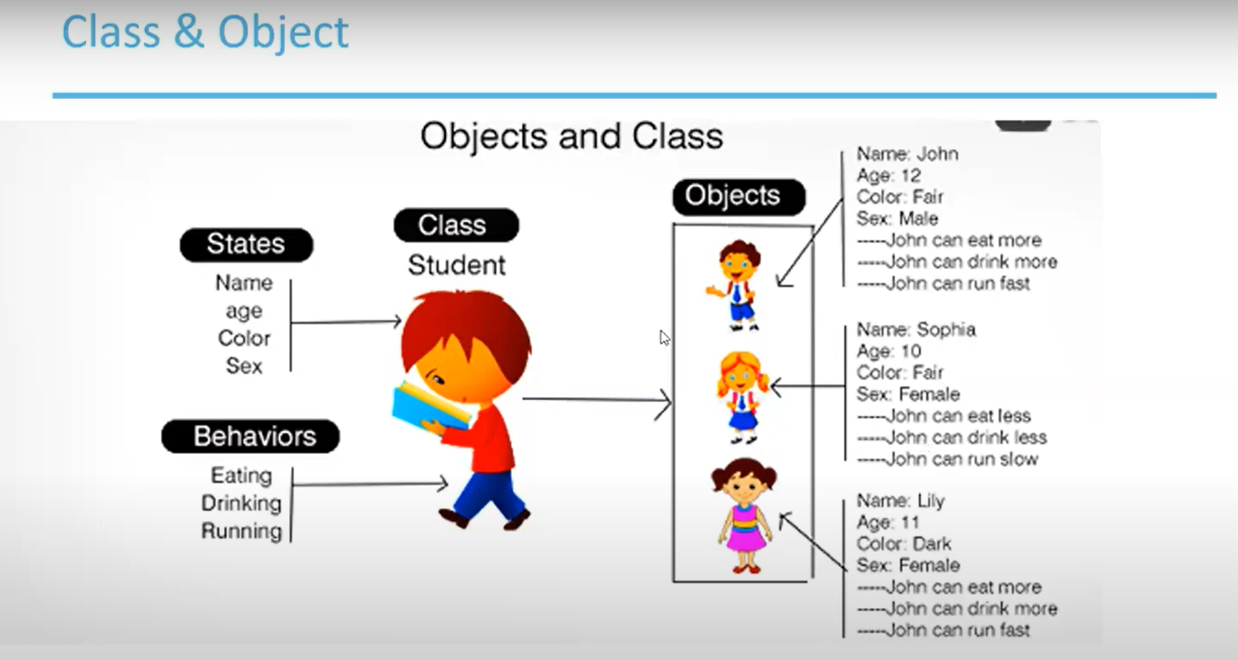

### Initialize variables using Object Variable

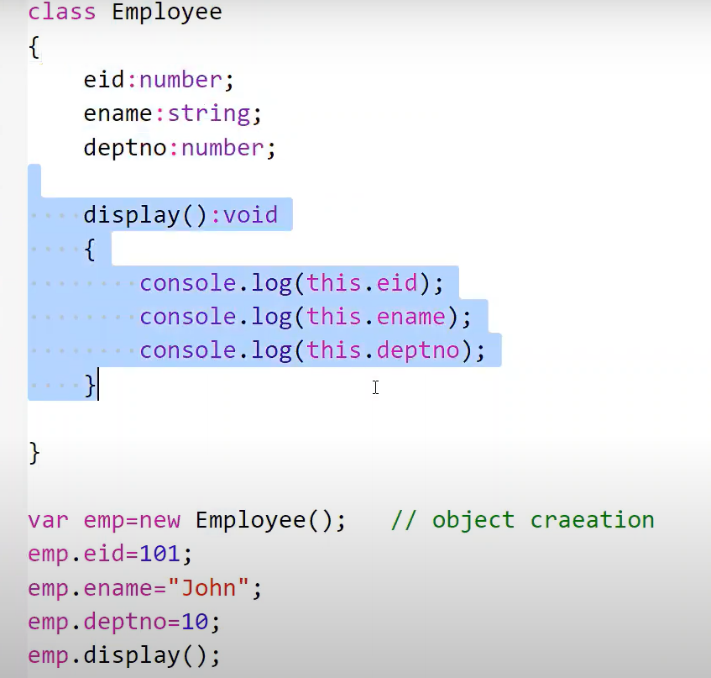

### Initialize variable using method:

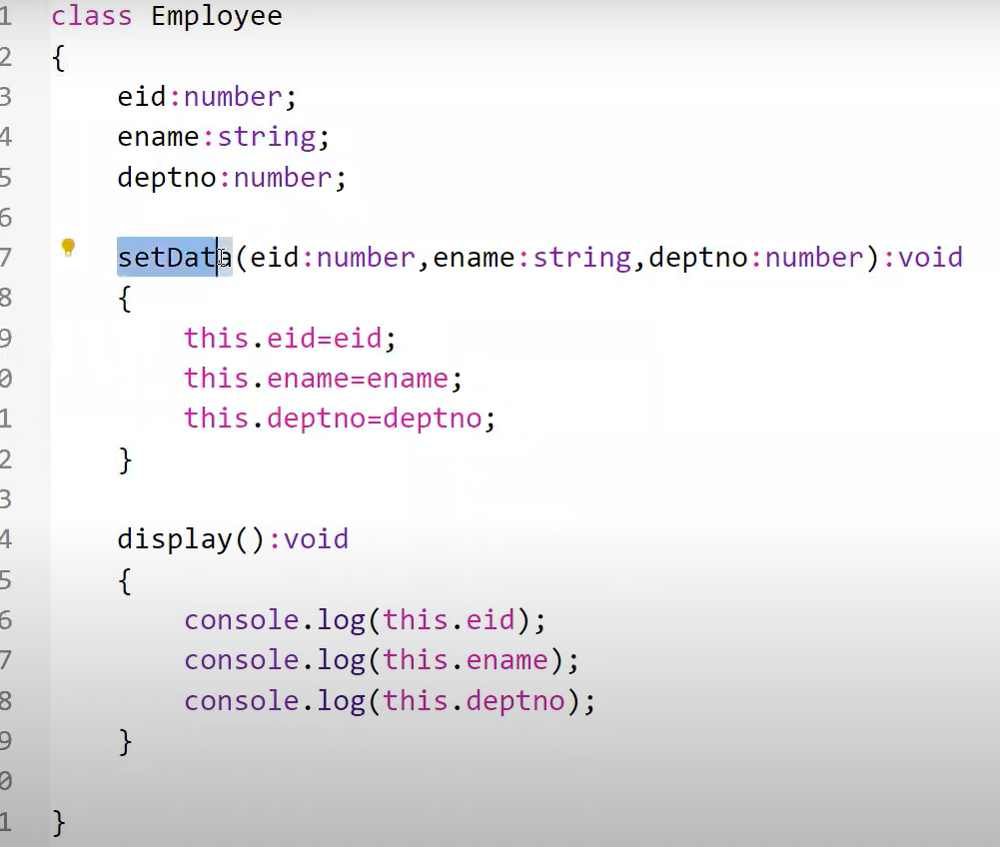

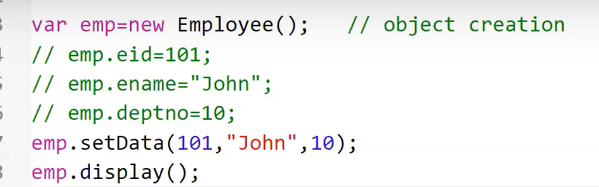

### Initialize variables using Constructor:

## Constructor is used to initialize the data into variable.

## It is like a method, but the name of the constructor should always be **constructor keyword**.

## Constructor can always accept the argument like method. Constructor doesn’t return any value even void.

## Whenever we create object for the class the constructor will be automatically invoked so we don’t need to call the constructor explicitly.

## If we create a method, we must call the method explicitly through object.

## At the time of object creation, we have to pass the data.

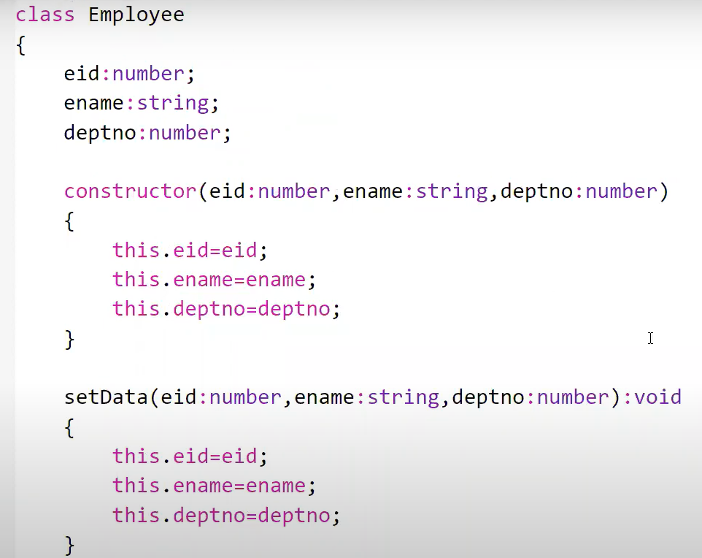

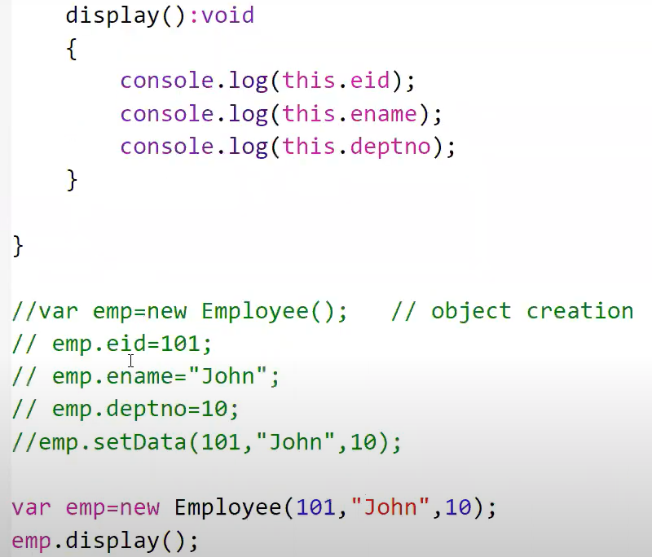

### Inheritance

## Inheritance is acquiring all the variables and methods from one class to another class.

## It helps to reuse the code and establish a relationship between different classes.

## Parent Class (Super or Base Class)

## Child Class (Subclass or Derived Class)

## A class which inherits the properties is known as Child Class whereas a class whose properties are inherited is knows as Parent Class.

## TypeScript classes can be extended to create new classes with inheritance, using the keyword extends.

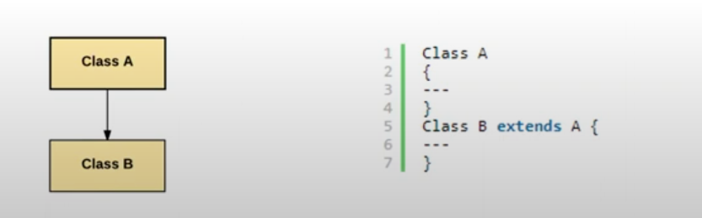

## Super keyword will invoke the immediate parent class constructor.

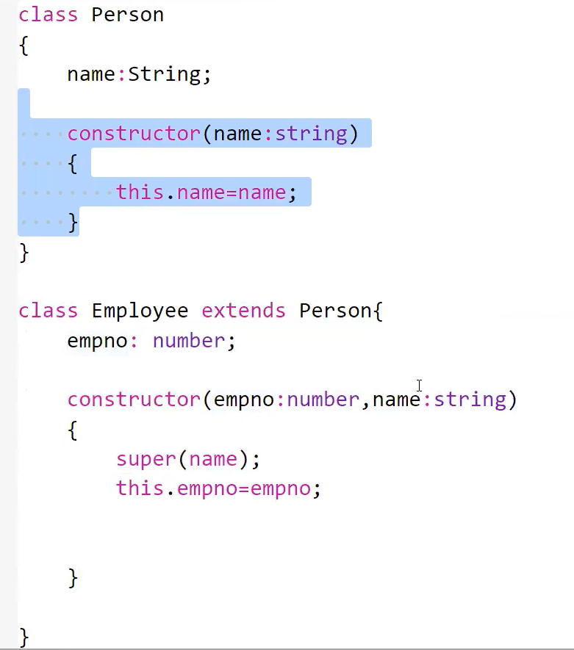

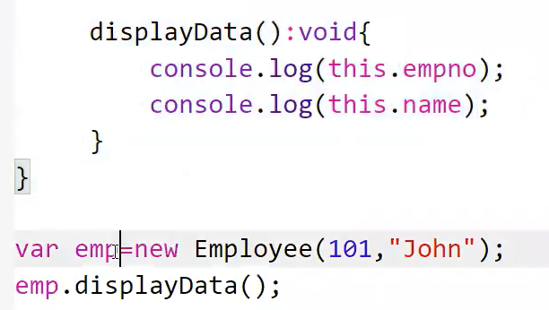

### Method Overriding

## Whatever method we created in the parent class and this method is also belong to child class after extends.

## Now whatever implementation is done in the parent class for that method if we don’t like that implementation then we can re-implement or re-create that same method in the child class but the method definition like method name, parameter, return type will not change only the body can be changed.

## We can override variables and methods as well.

## Basically, whatever implementation is done in the parent class if we change or modify that implementation in child class which is called the overriding.

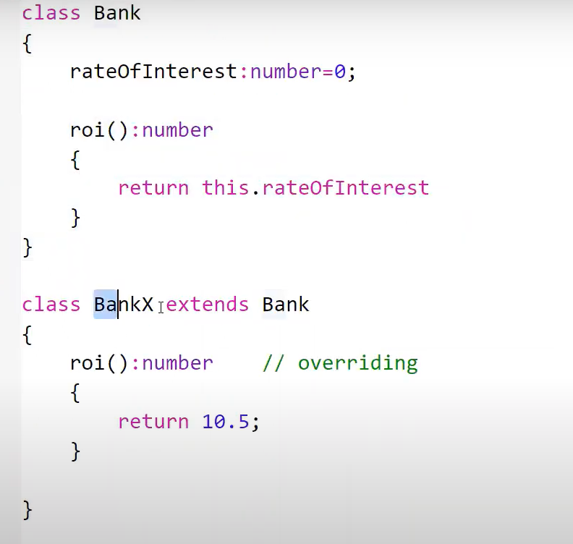

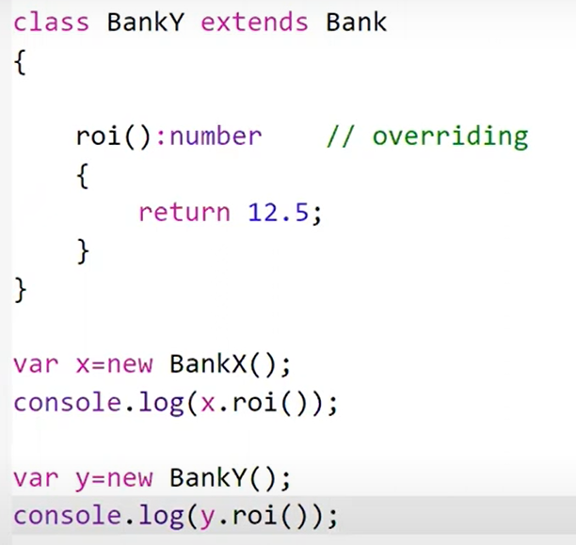

### Interface

## Interface contains variables and methods.

## It will contain only the definition of the methods(unimplemented methods).

## Use **interface** **keyword** to create interface.

## Sometimes we know the requirement what to develop but we don’t know how to develop(don’t know design part).

## In those stages initial stages, we will create interface. Then in later part when we know how to design then we can implement the interface using some other class.

## Whatever methods we have mentioned in the interface we have to implement them using the class.

## Interface is a structure that defines the contract in our application.

## It defines the syntax for classes to follow.

## The TypeScript compiler does not convert interface to JavaScript. It uses interface for type checking. This is also known as “duck typing” or “structural subtyping”.

## Any interface is defined with the keyword interface, and it can include properties and method declarations using a function or an arrow function.

## An interface extends another interface.

## A class implements interface.

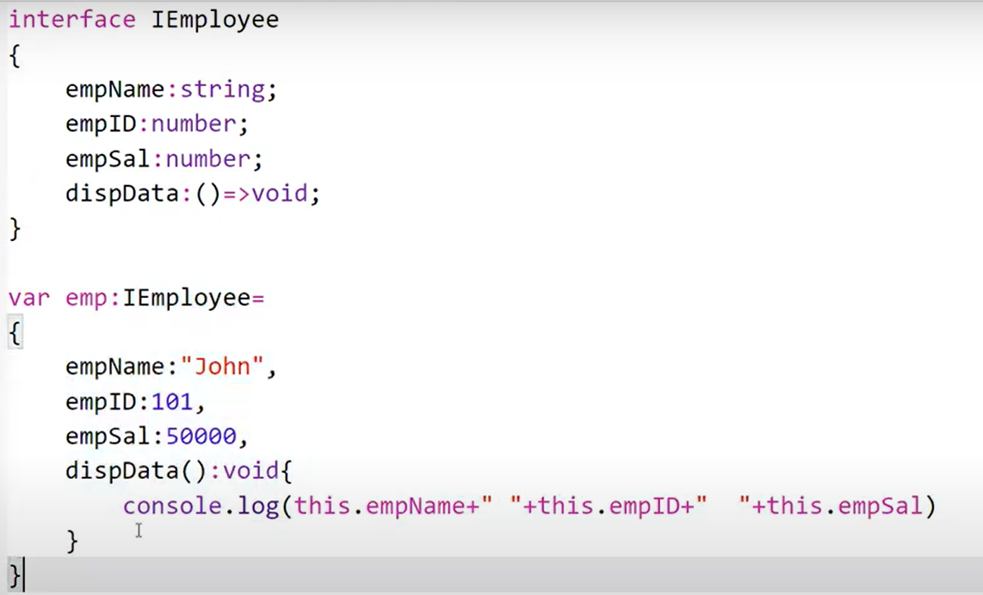

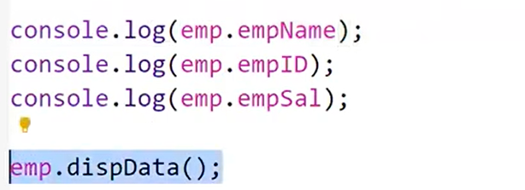

### Interface extends interface:

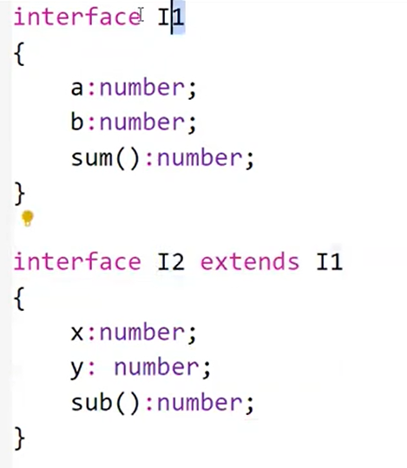

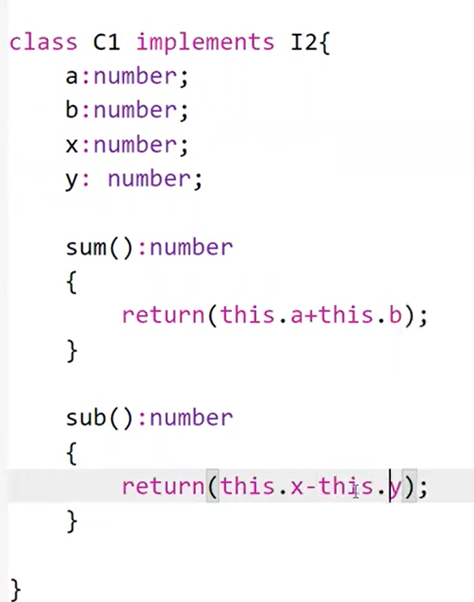

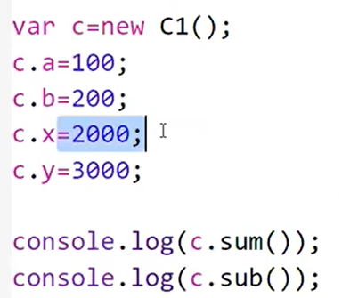

### Modules

## The files created in typescript have global access, which means that variables declared in one file are easily accessed in another file.

## This global nature can cause code conflicts and can cause issues with execution at run-time.

## We have export and import module functionality which can be used to avoid global variable, function conflicts.

## This feature is available in JavaScript with ES6 release and also supported in TypeScript.

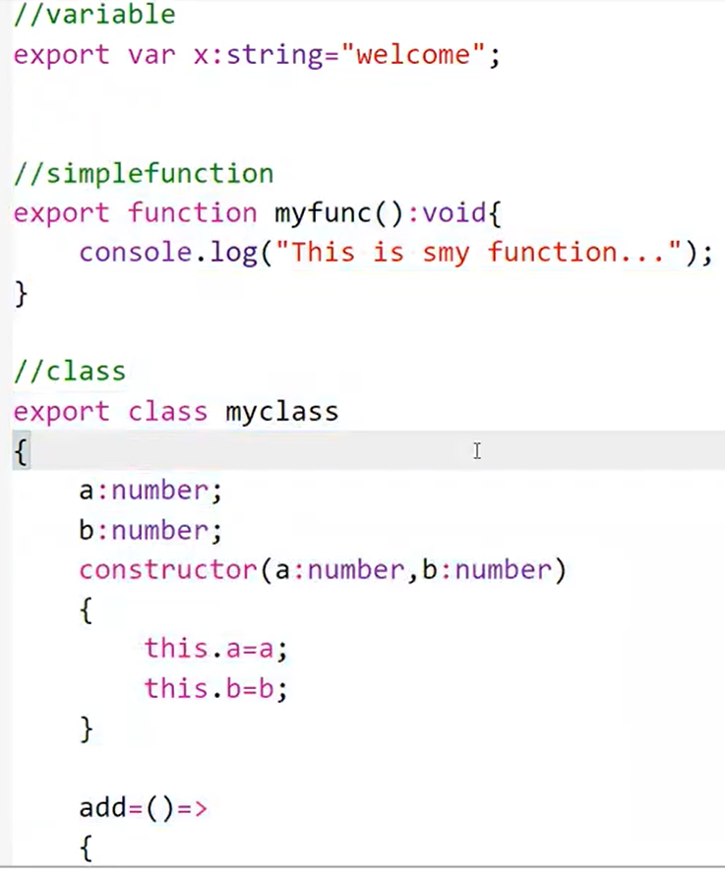

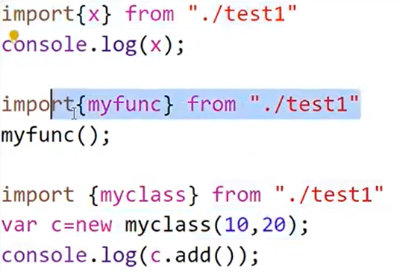

## To convert to JavaScript, we cannot compile directly so we have to use commonjs module to compile to JavaScript.



### Type Assertions

## Type Assertions in TypeScript is a way to tell the TypeScript compiler that we know more about the type of a value than it does.

## Type assertion is a technique that informs the compiler about the type of a variable.

## We can either use <> angular brackets or as keywords to do type assertion.

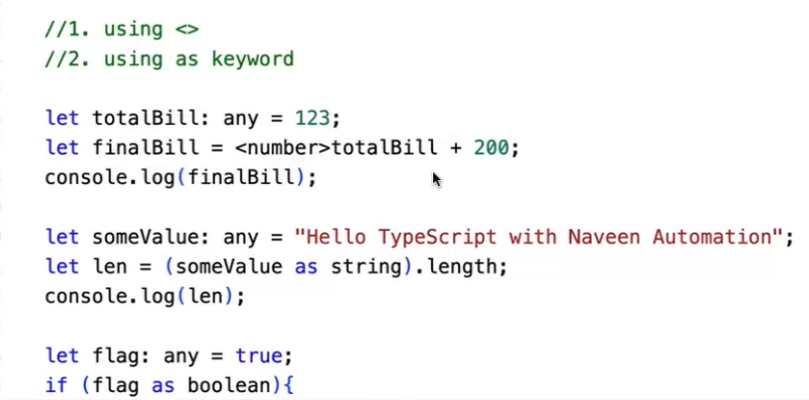

### Ternary Operator

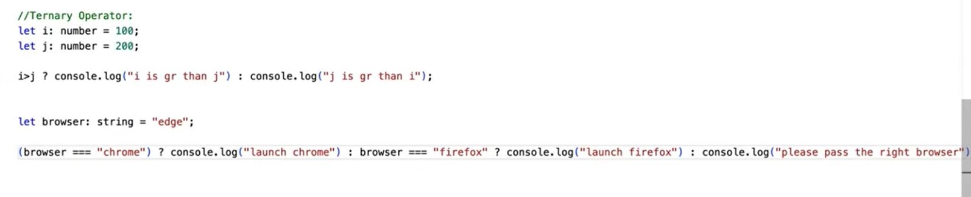

### When to use while and for loops

